PROJECT 1

WELCOME SCREEN

**CODES & OUTPUTS:**

1. **MAIN MENU:**

* Code:

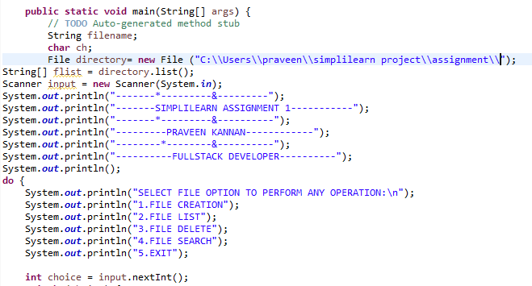

Output:

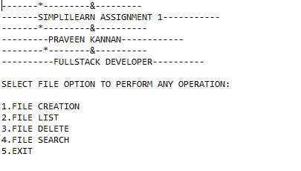

* Here we can see that in output the main menu data’s has been created.
* We can give the numbers to proceed to the next possible steps.

**2.DELETING FILE:**

code:

* Here we are using **try & catch method** for creating a file the specific folder.
* And the **if else conditional statement** is used for the showing whether the filename already exist or not.

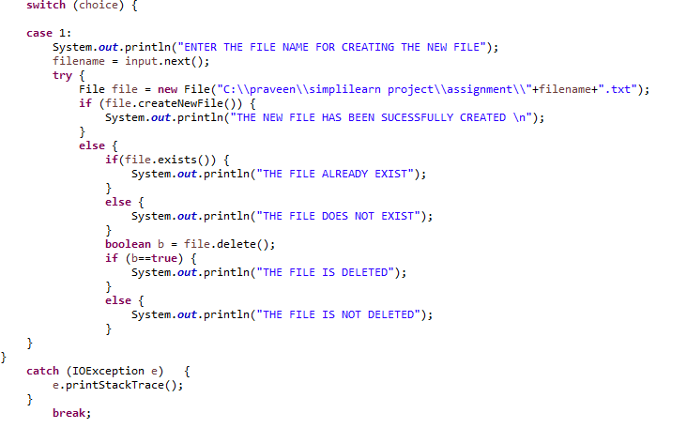

**Output:**

* First step of creating the file:

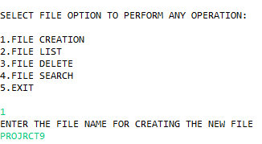

* Now we have give a file name then a file will be created in the designated path.

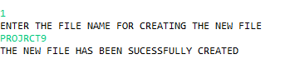

**LIST OF FILES:**

**CODE:**

* First we have to give the create **a listOfFiles()** method I case 2.

**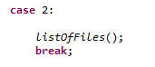**

* That we were defined in the private class.
* There we have given the directory location to acess the files .
* Then we have used the **if-else conditional statement** to make the output considerable.

**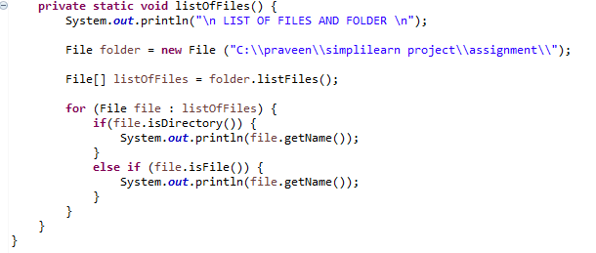**

**OUTPUT OF LIST OF FILES:**

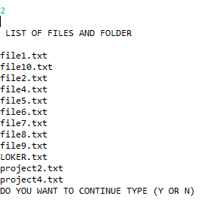

**DELETEING A FILE:**

**CODE:**

* In the deleting of files first we have to proceed with the same step here by denoting the location of the file we have to access to.
* If else condition statement and the for loop have been used to identify the file and give the considerable output.

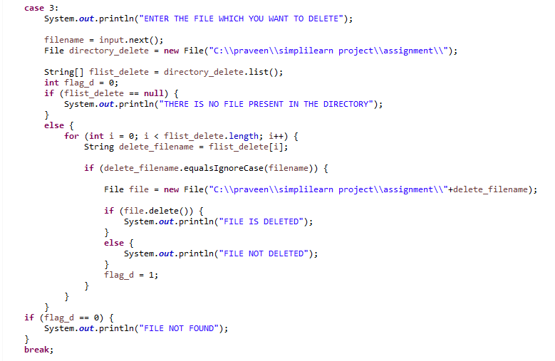

**OUT OF DELETING THE FILE:**

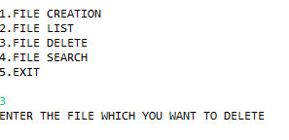

* First we have to give number 3 to continue for deleting the file.

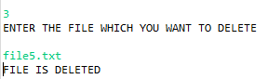

* Here we have to give the particular file name to proceed the deleting the file operation.

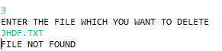

* When you given a wrong file name or the file not present in the particular folder it will show **file not found** as the output.

**SEARCHING THE FILE:**

**CODE:**

* As the searching of the file also need the file location so we have to denote the directory to locate the file for searching.
* As we have done in the deleting of file the same procrdure is followed in the searching of the file.

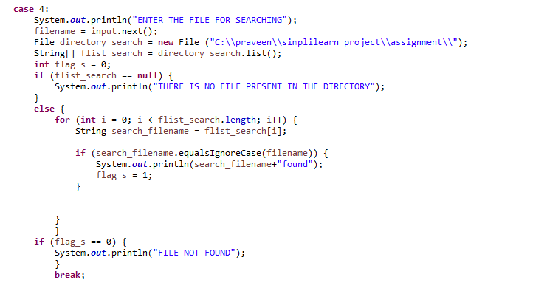

**OUTPUT OF THE SEARCHING OF THE FILE:**

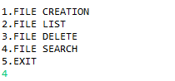

* Here we have give the number 4 to proceed with search operation.

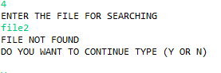

* When we give the file name which is the present or gave the wrong name the output shows as **file not found**.

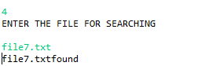

* If we gave the correct name it will shoe as found.

**Exit the operation:**

**Code:**

code_fileexit.PNG

**OUTPUT :**

exitoutput.PNG

* As per the code it will show **thankyou user**.

**